# LAB ASSIGNMENT-9

TASK-1:

Prompt:

Generate a Google-Style Docstring describing the python function to return sum of even and odd numbers in the given list.

Code and Output:

GitHub Copilot:

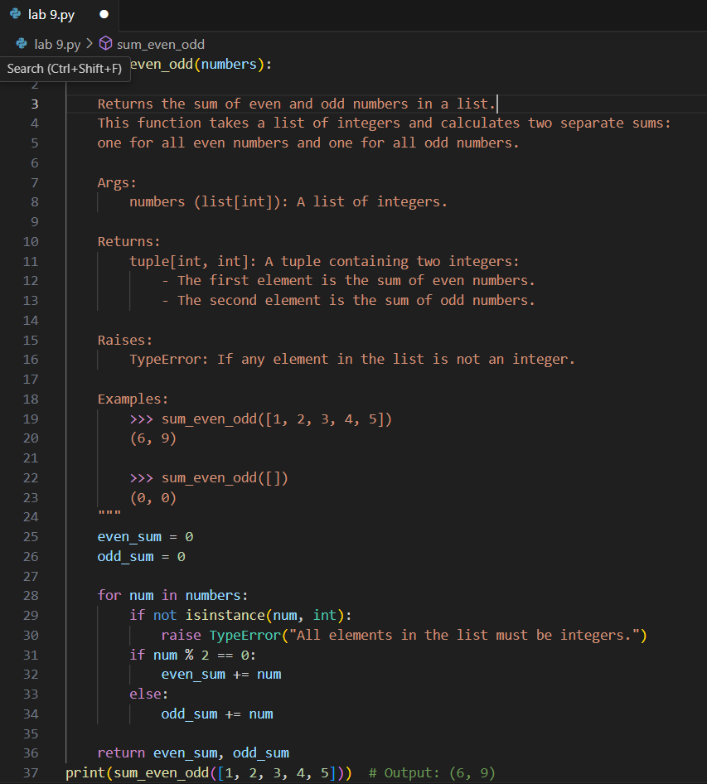

Gemini:

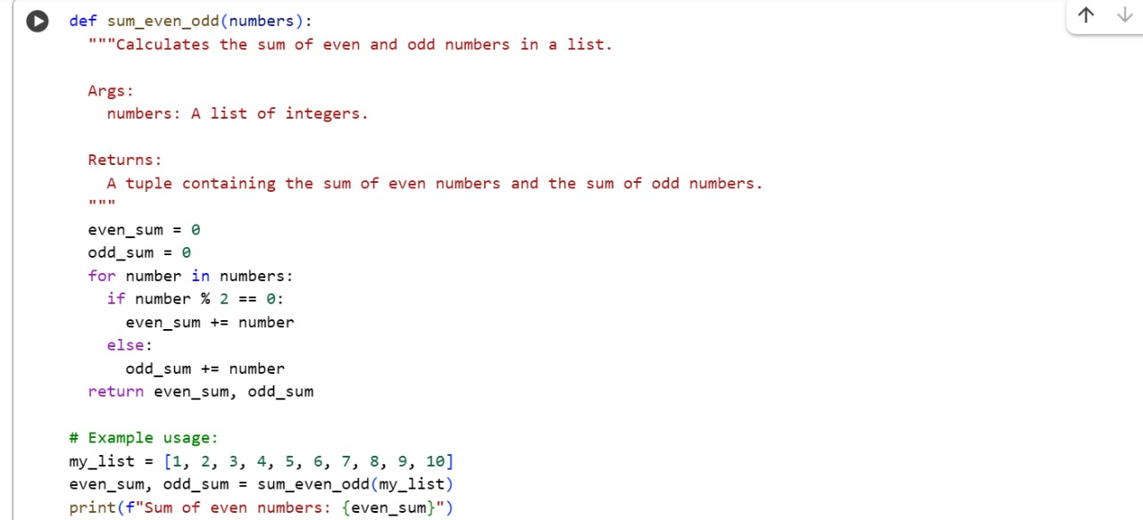



TASK-2:

Prompt:

Generate python program for sru_student class with attributes like name, roll no., hostel_status and fee_update method and display_details method. Write comments manually for each line/code block/step.

Code and Output:

GitHub Copilot:

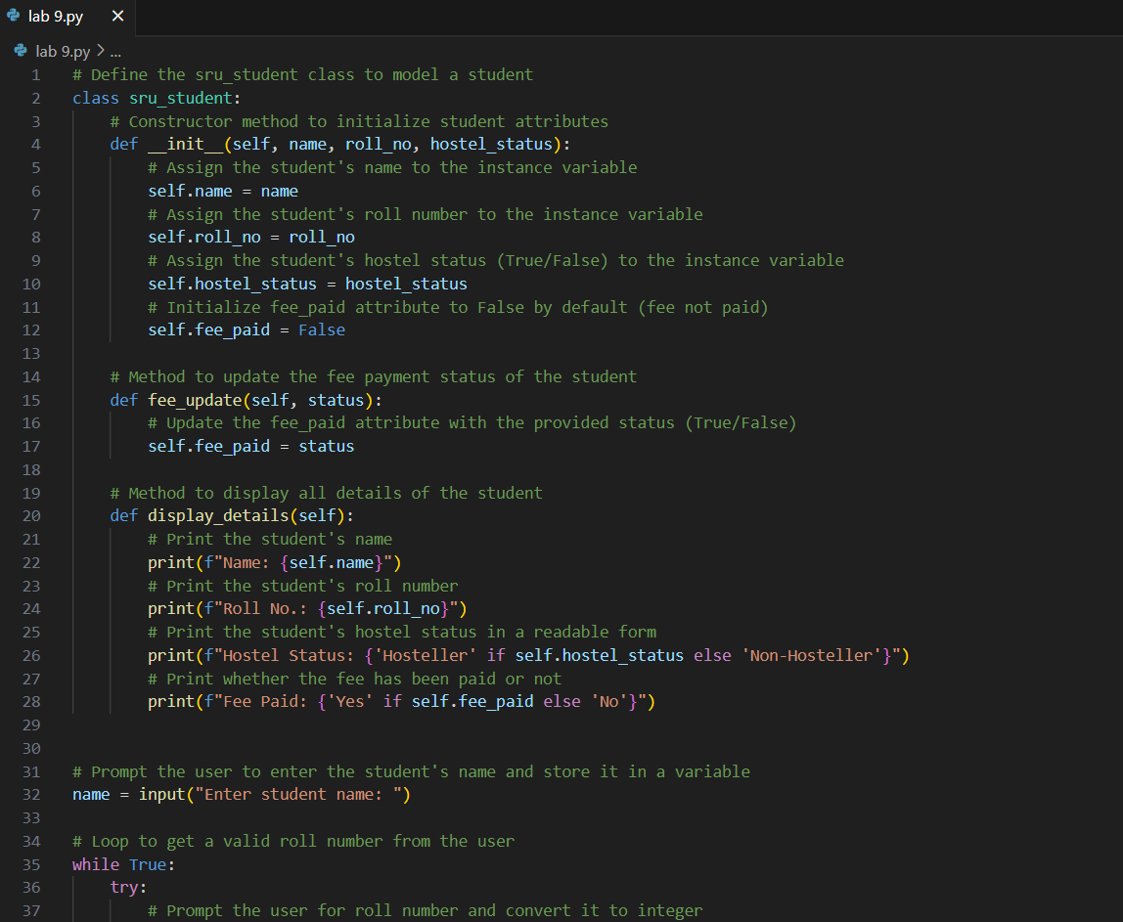

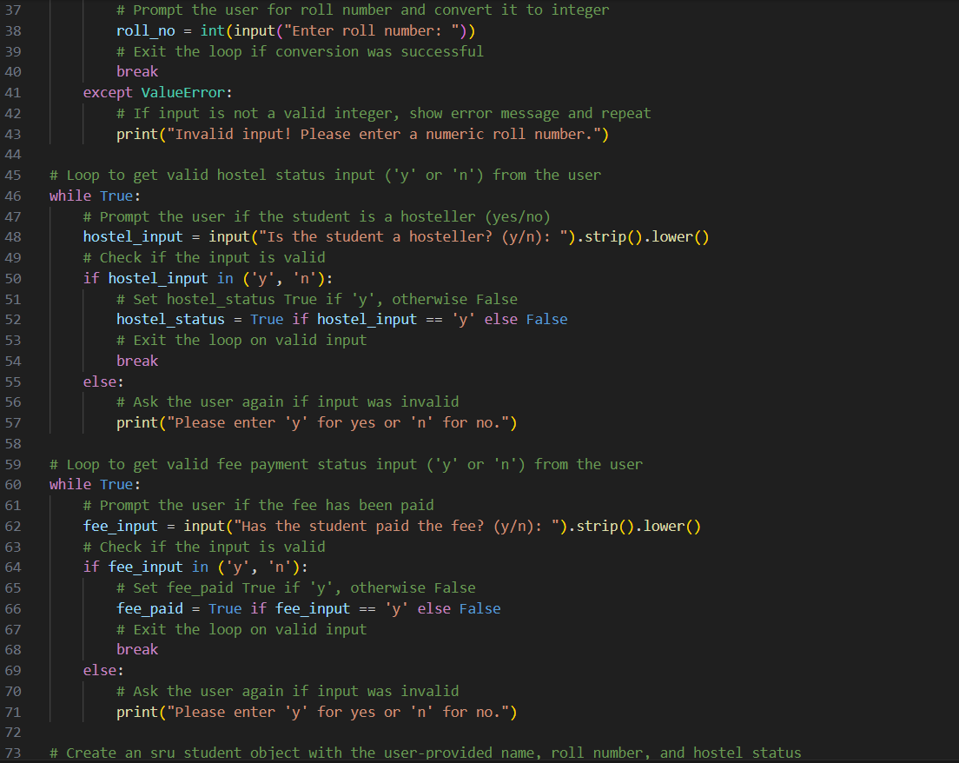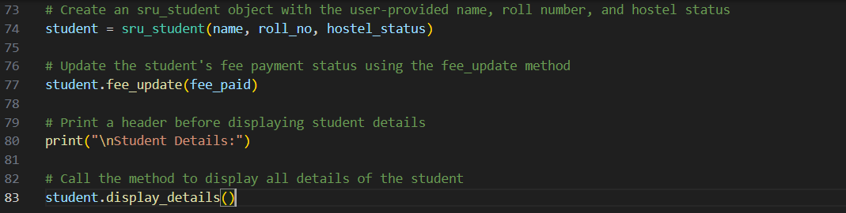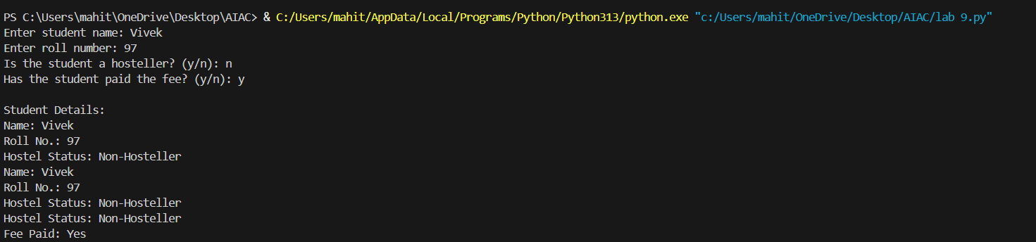

Gemini:

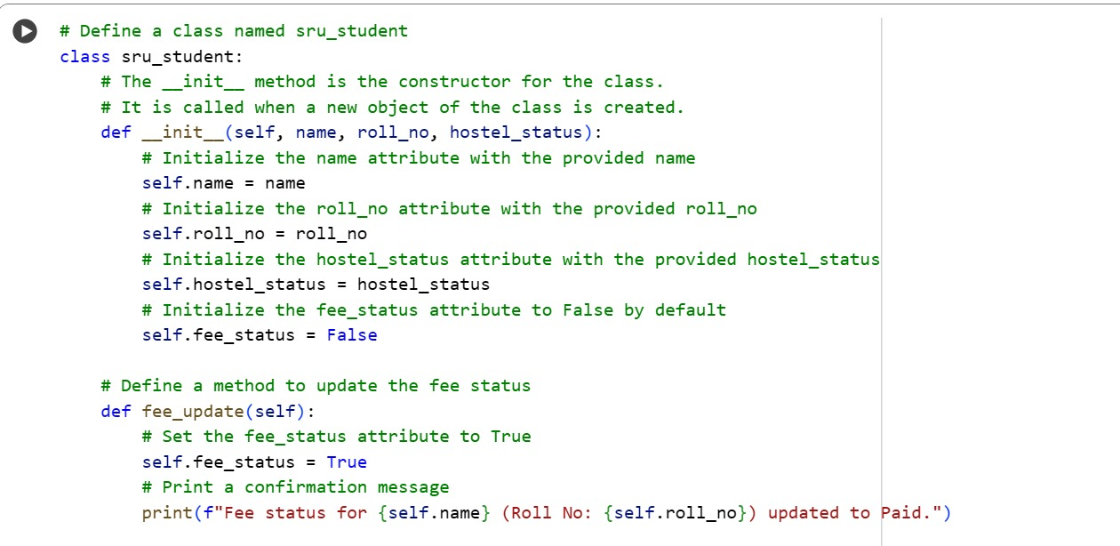

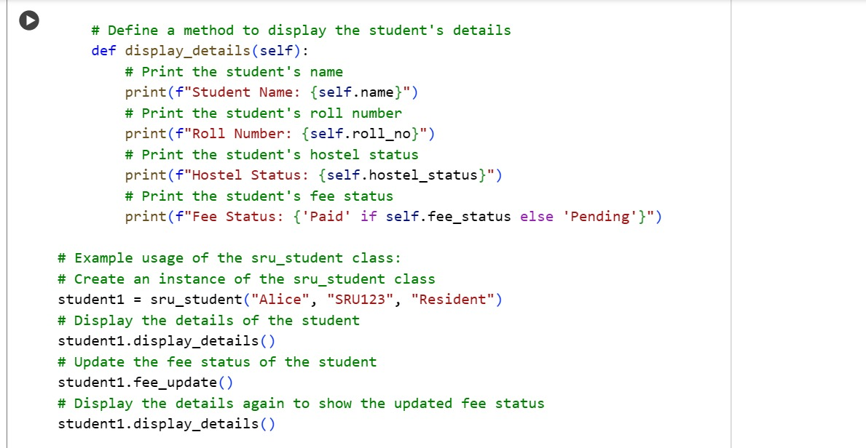

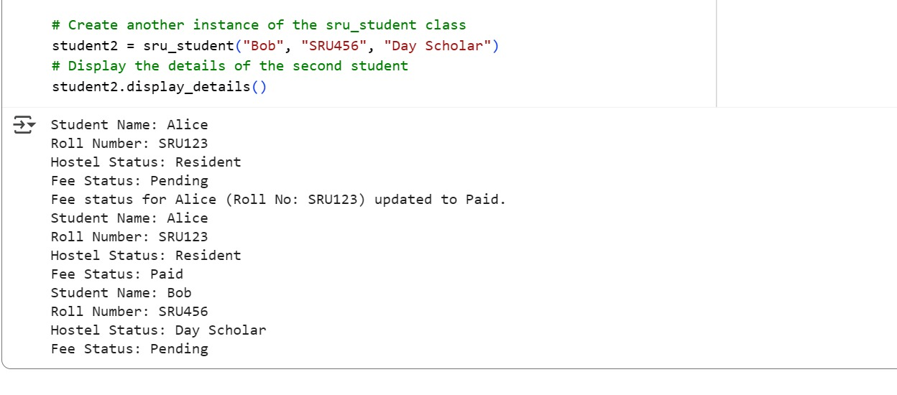

TASK-3:

GitHub Copilot:

Prompt:

Generate a Python script with 3–4 functions (e.g., calculator: add, subtract, multiply, divide). Include module-level docstring + individual function docstrings.

Code and Output:

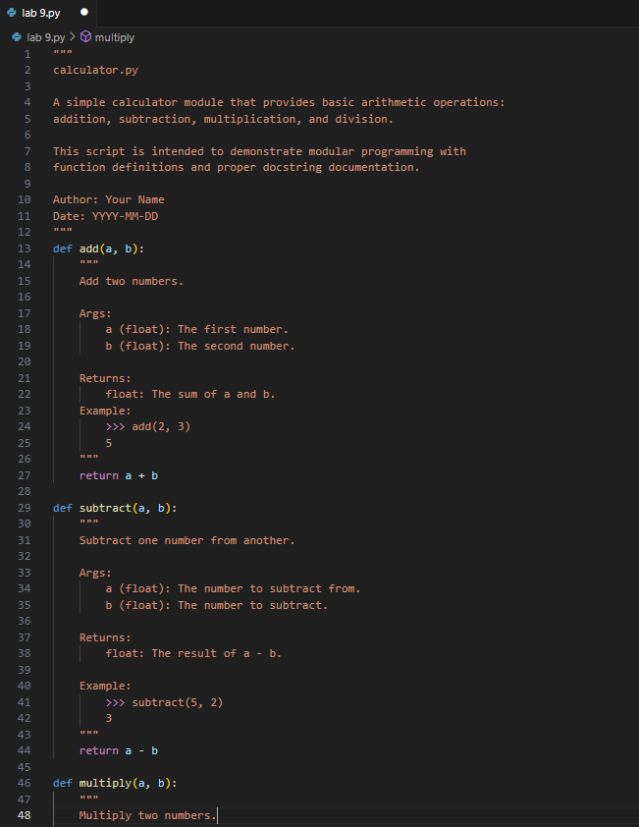

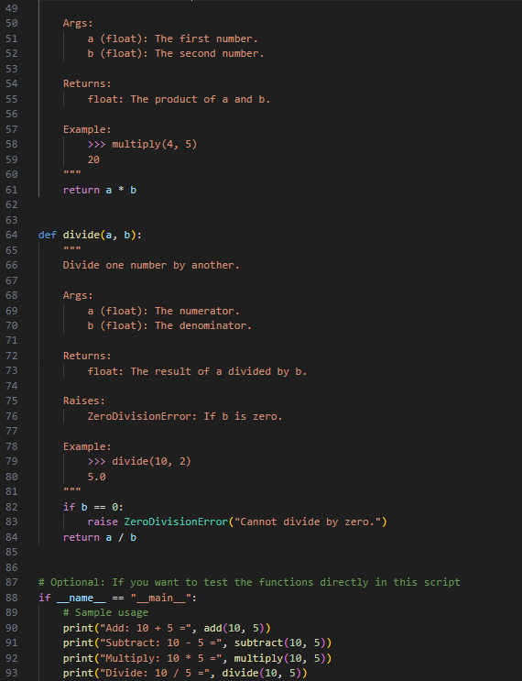

Gemini:

Prompt:

Generate a Python script with 3–4 functions (e.g., calculator: add, subtract, multiply, divide) . Write docstring in code with NumPy Style

Code and Output:

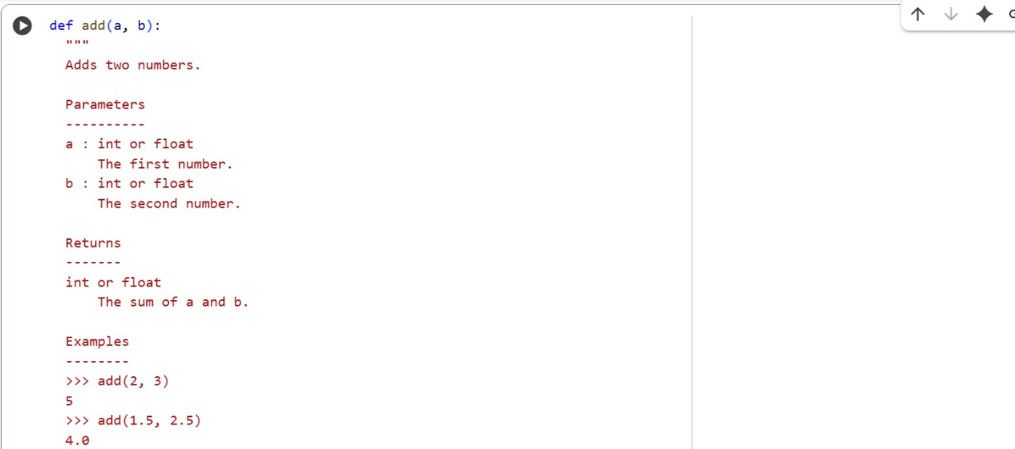

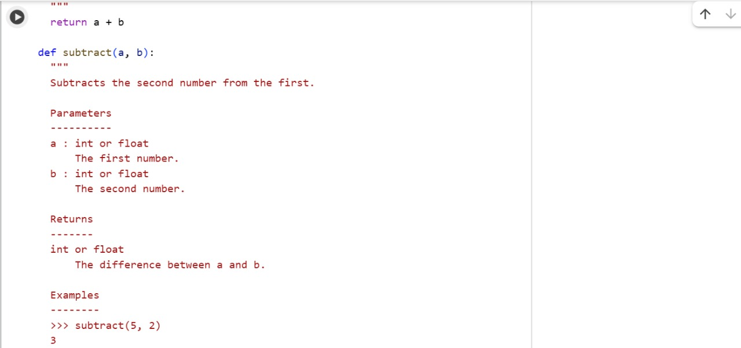

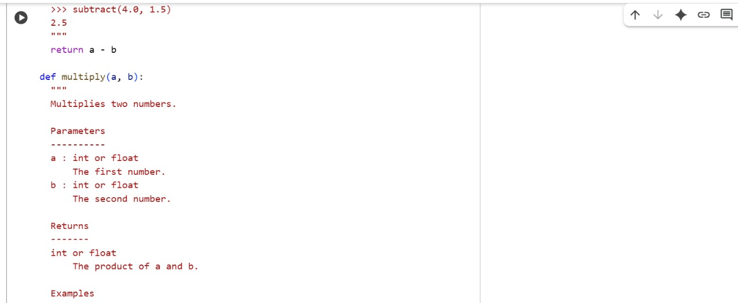

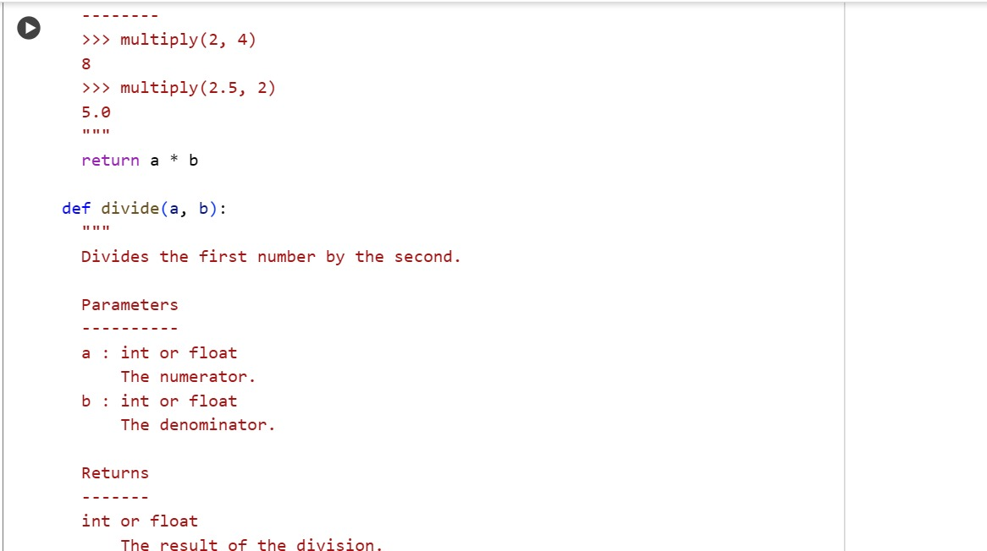

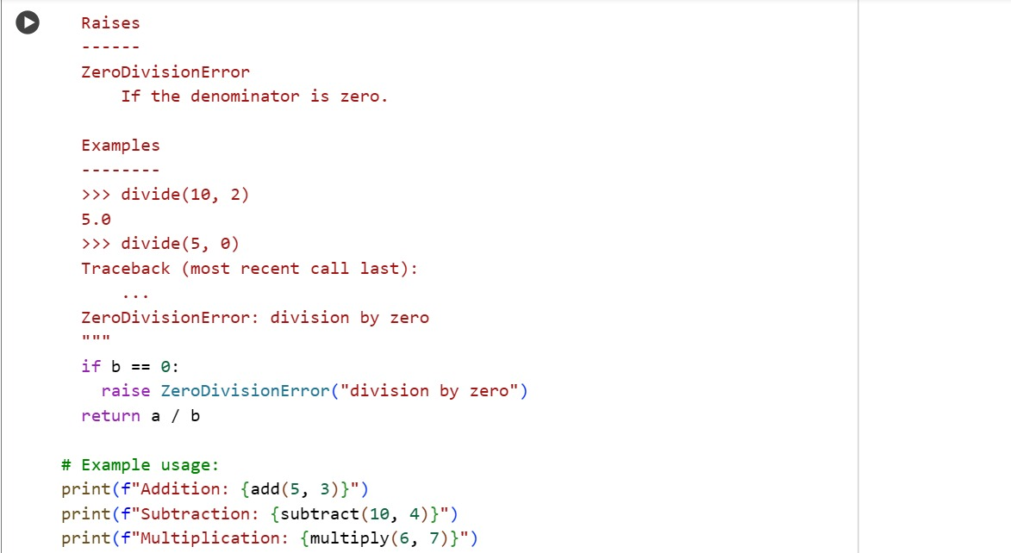

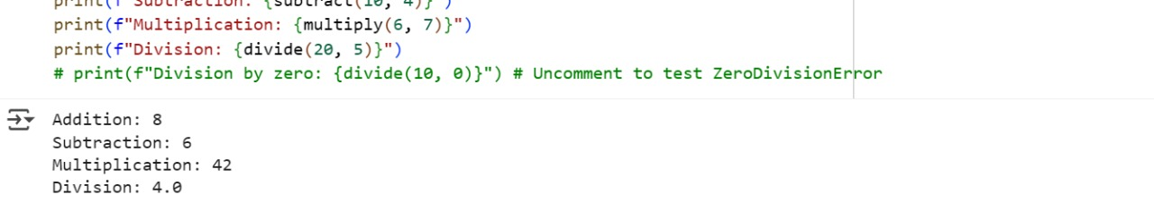

Comparison: Google-style vs NumPy-style

**Readability**:

* *Google-style* is cleaner and easier for beginners to read.
* *NumPy-style* is more structured, preferred in scientific computing.

**Parameters**:

* *Google-style*: Uses Args: with simple name-type-description format.
* *NumPy-style*: Uses a Parameters section with aligned formatting.

**Return values**:

* *Google-style*: Returns: with brief description.
* *NumPy-style*: Returns block includes type and detailed explanation.

**Exceptions**:

* Both styles support Raises: or Raises section, but NumPy-style is more detailed.

**Examples**:

* *Google-style*: Examples: section uses inline >>> syntax.
* *NumPy-style*: Examples section is more formal, under its own heading.

**Usage**:

* *Google-style*: Common in web apps, general Python projects.
* *NumPy-style*: Standard in scientific libraries (NumPy, Pandas, etc.).

**Tooling**:

* Both are compatible with Sphinx; *NumPy-style* works best with napoleon extension for auto-doc generation.